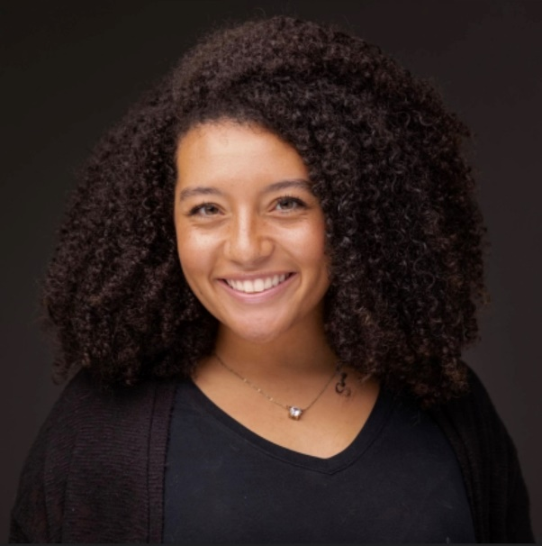

Haley Massa grew up in Nashville, Tennessee, and moved to Florida after graduating high school to pursue her Bachelor's of Science in Athletic Training at the University of Tampa. During her time at the University of Tampa, she worked with various sports teams, including men's lacrosse at the D2 level, men's and women's soccer, softball, and men's basketball. Prior to relocating to Georgia, she also worked with student-athletes at Clearwater High School.

Haley holds an athletic training license from the state of Georgia and has been certified in CPR by both the Red Cross and American Heart Association. In the summer of 2022, she joined the Northside Hospital/Source Fitness Management team, and we're thrilled to have her on our Mountain View sports medicine staff!

**haley.massa@sourceatlanta.com**